Appendix 19: SWIFT Child Safety Module Interview: Information Sheet and Consent Form
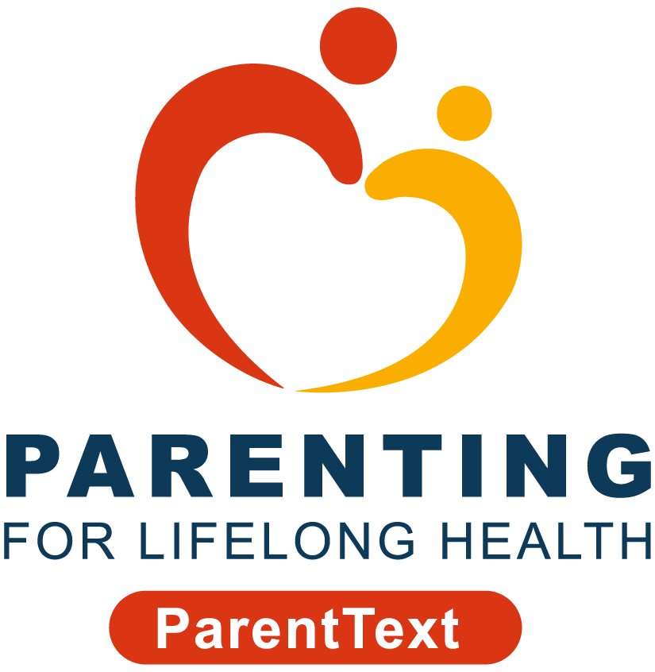
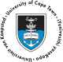


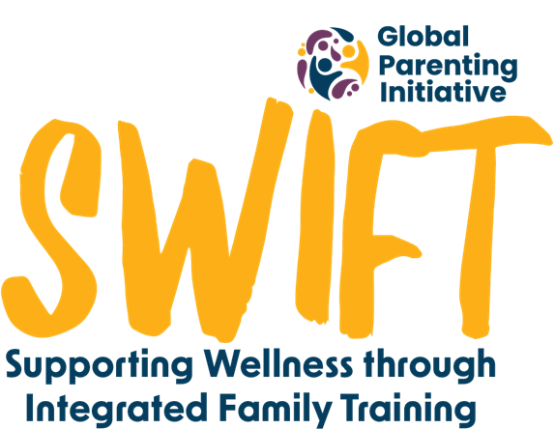
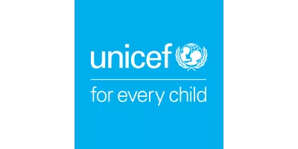

Your experience with the ParentText programme is vital to our study. We would love to hear about your experience of the ‘Keeping My Child Safe’ module. This interview is part of a study carried out by researchers from the Universities of Cape Town in South Africa and the University of Oxford in the United Kingdom.
Before you decide if you’d like to be interviewed, it’s important for you to know why we’re doing this research and what participating in it would involve. All the information you might need is explained below but if you have any questions about your participation or our study, please email the study team at swift@globalparenting.org or message us on WhatsApp at +27 XX XXX XXXX. We’re here to help you!
What will my interview look like and what is expected of me?
We would like to have a telephonic conversation with you which will last a maximum of 45 minutes. One of our researchers will call you to speak to you at a time that is convenient for you. There are no right or wrong answers, we just want to hear your experience and opinion of the chatbot. Please make sure that when we call, that you only let the interview start when you are in a private space where you feel comfortable to talk without being overheard or interrupted. If while you are being interviewed, you are interrupted, please ask the researcher to pause until you feel safe to continue talking.
Why have I been invited to the interview?
We would like to know more about your experience with the Keeping My Child Safe module. Your opinions will help us improve the module, and hopefully improve the experience of other parents like you in the future.
Do I have to agree to be interviewed?
No, it's up to you if you want to be interviewed or not. If you don't want to be interviewed, there will be no implications to you or your family. If you do choose to be interviewed but don't want to answer some questions, you can skip these or stop at any time by telling your interviewer.
What happens with my information?
To protect your personal information (including your real name, contact details, and any other information that can identify you), we will give you a participant number, and you can choose a name you want us to call you during the interview.
With your permission, we will record the interview to help us remember the discussion and later write down what was said. We will delete any personal information we collect from you at the end of the study and, after transcribing your interview, change any data which might lead to identification at the point of transcription. We may use an artificial intelligence (AI) software, Microsoft Transcriber, to transcribe the interviews at first, and then we will check/review these transcriptions. This AI-generated information will be processed and stored securely on password-protected University of Cape Town servers, and in accordance with POPIA. Only authorised members of the research team will be able to access it, and this data will be owned by the Global Parenting Initiative at the University of Cape Town.
Do I get anything for being interviewed?
As a thank you for taking part in the discussion, we'll give you a R30 airtime voucher/data bundle.
What happens to my information if I agree to be interviewed?
We only collect what’s needed for the study and store it securely. Your information, like your consent form and interview recording, and any information you provide via email or WhatsApp, will be kept safe on secure servers at the University of Cape Town.
Interview recordings will be deleted after we have written our notes. Any details that identify you will be kept separate and only authorised staff can access them. All data will be kept for five years after the study, but personal information will be deleted when the study ends.
Ethics committees and monitors may check the information. Your information will stay private unless the law says otherwise. After the study, we may share the information with other researchers but without your details. You have the right to see, correct, or ask us to delete your personal information.
You have the right to request access to your data, to correct any mistakes in your data, and to request us to delete it or transfer it somewhere else. Please email the study team before [*date to be determined] if you would like to do any of these.
Your participation and what you tell us will help us understand how to support families like yours. We plan to share the results in reports and at conferences so others can learn from this study too.
Who are some of the study team members?
The principal investigators of this study are Prof Cathy Ward and Cindee Bruyns and the Co-investigator is Carly Katzef all from the University of Cape Town.
Are there any risks in being interviewed?
We don’t expect any risks to you if you are interviewed. If any questions make you uncomfortable, you don’t have to answer them. If you become upset during the interview, you can let your interviewer know. Remember, you can stop participating anytime without giving a reason. We care about your well-being.
We also want to make sure you're safe. If we notice that you or your family are in serious danger, we might refer you for support or could need to ask for help from other places outside of this study, like social or medical services.
Who pays for the study?
This study is part of the Global Parenting Initiative, funded by the LEGO Foundation, Oak Foundation, the World Childhood Foundation, The Human Safety Net, and the UK Research and Innovation Global Challenges Research Fund.
Data protection
The University Cape Town makes sure your personal information is used safely and correctly, just for research. The study follows data protection laws like GDPR (General Data Protection Regulation) in the UK and POPIA (Protection of Personal Information Act) in South Africa. Any data that is transferred across borders will comply with POPIA.
Who has approved this study?
[Once the ethics has been approved this will read as follows: This study has received approval from the University of Cape Town’s Centre for Social Science Research Ethics Committee and University of Cape Town’s Faculty of Health Sciences Human Research Ethics Committee. The study has also been approved by the Western Cape Department of Health and Wellness and Department of Social Development, and City of Cape Town’s City health.]
Who do I contact if I have questions or concerns?
If you have any questions or concerns about your rights as a study participant, you can contact the study team at swift@globalparenting.org or on WhatsApp at +27 XX XXX XXXX (messages only).
If you have more questions or concerns about your rights, you can contact one of the ethics committees listed:
Name | Telephone | Email
University of Cape Town Centre for Social Science Research | +27 21 650 4656 | cssr@uct.ac.za
Human Research Ethics Committee |  | hrec-enquiries@uct.ac.za

Informed Telephonic consent to take part in the study
Please respond with the word “agree” to each as I go through each of the following points. If you don’t agree, we can go over any other information you need to make your decision and if you still agree then we can proceed:
- Someone from the research team has gone over all the information above and I know what I need to do.
- I had time to think about the information and ask questions. I am happy with the answers which I got.
- I know I can say yes or no to being in the study. If I say yes, I can stop any time before the [*date to still be determined] without saying why, and nothing bad will happen.
- I am okay with the interview being recorded. I know the recordings will be used for research.
- I know who can see my information after the interview, how it will be kept safe, and what happens to it after the study.
- I know I can request access to my data, correct any mistakes, ask to delete it, or for it to be transferred somewhere else.
- I know that I won’t be named in any papers or reports from this study.
- I know who to tell if I have a problem with the study.
- I can be contacted again if more information is needed from me.
- I understand the team will keep my contact information safe so they can tell me about the results of the study.

